Data Structure and Algorithm

Laboratory Activity No. 4

Arrays

|  |  |
| --- | --- |
| *Submitted by:* | *Instructor:* |
| Polestico,Paul Justine D. | Engr. Maria Rizette H. Sayo |

August,09, 2025

# Objectives

Introduction

Array, in general, refers to an orderly arrangement of data elements. Array is a type of data structure that stores data elements in adjacent locations. Array is considered as linear data structure that stores elements of same data types. Hence, it is also called as a linear homogenous data structure.

This laboratory activity aims to implement the principles and techniques in:

* Writing algorithms using Array data structure
* Solve programming problems using dynamic memory allocation, arrays and pointers

# Methods

Jenna’s Grocery

Jenna wants to buy the following fruits and vegetables for her daily consumption. However, she needs to distinguish between fruit and vegetable, as well as calculate the sum of prices that she has to pay in total.

Problem 1: Create a class for the fruit and the vegetable classes. Each class must have a constructor, deconstructor, copy constructor and copy assignment operator. They must also have all relevant attributes (such as name, price and quantity) and functions (such as calculate sum) as presented in the problem description above.

Problem 2: Create an array GroceryList in the driver code that will contain all items in Jenna’s Grocery List. You must then access each saved instance and display all details about the items.

Problem 3: Create a function TotalSum that will calculate the sum of all objects listed in Jenna’s Grocery List.

Problem 4: Delete the Lettuce from Jenna’s GroceryList list and de-allocate the memory assigned.

# Results

Present the visualized procedures done. Also present the results with corresponding data visualizations such as graphs, charts, tables, or image . Please provide insights, commentaries, or explanations regarding the data. If an explanation requires the support of literature such as academic journals, books, magazines, reports, or web articles please cite and reference them using the IEEE format.

Please take note of the styles on the style ribbon as these would serve as the style format of this laboratory report. The body style is Times New Roman size 12, line spacing: 1.5. Body text should be in Justified alignment, while captions should be center-aligned. Images should be readable and include captions. Please refer to the sample below:

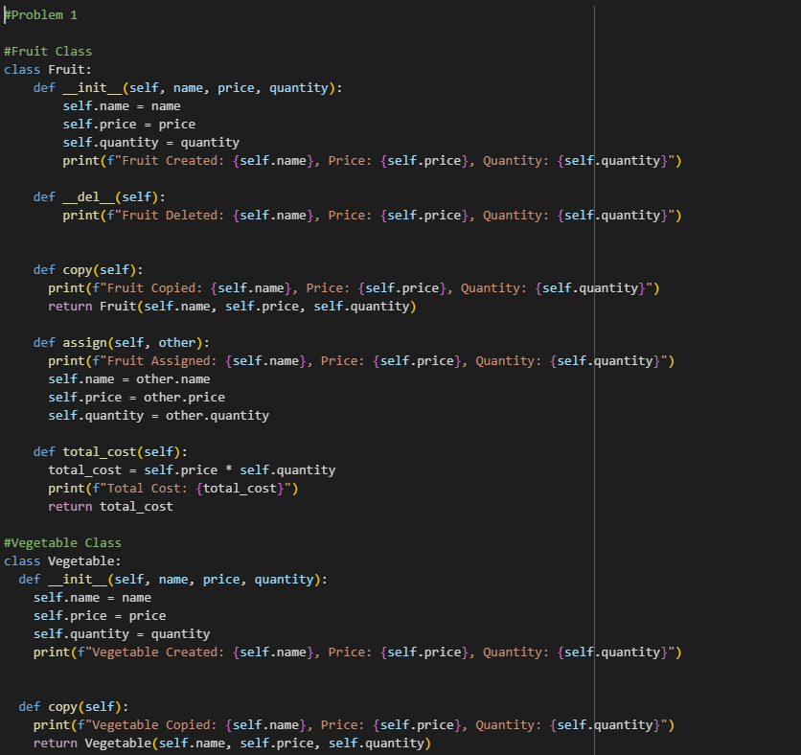

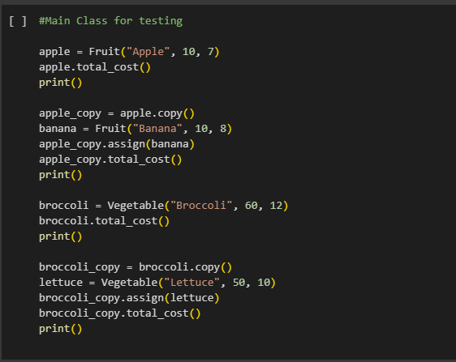

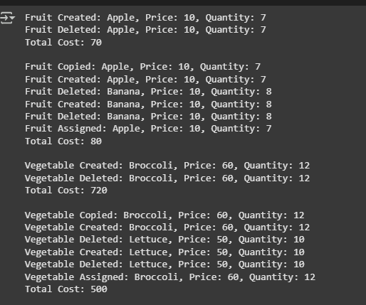

Figure 1 Screenshot of program

The Fruit and Vegetables classes are defined with the attributes name,price,and quantity. The program uses the first Fruit and Vegetable defined by the user,displaying the name,price,and quantity of that specific Fruit and Vegetable. After displaying the required information,the program would then compute for the total cost of each by multiplying the price and the quantity to each other,Then it would delete the first element,copy its attributes,and assign the attributes to the next one.

Conclusion

The conclusion expresses the summary of the whole laboratory report as perceived by the authors of the report.

**References**

[1] Co Arthur O.. “University of Caloocan City Computer Engineering Department Honor Code,” UCC-CpE Departmental Policies, 2020.

[2] GeeksforGeeks, “Constructors in Python,” *GeeksforGeeks*, Jul. 11, 2025. <https://www.geeksforgeeks.org/python/constructors-in-python/> (accessed August 9, 2025)

[3]GeeksforGeeks, “Destructors in Python,” *GeeksforGeeks*, Jul. 11, 2025. <https://www.geeksforgeeks.org/python/destructors-in-python/> (accessed August 9, 2025)

[4] GeeksforGeeks, “Copy Constructor in Python,” *GeeksforGeeks*, Jul. 23, 2025. <https://www.geeksforgeeks.org/python/copy-constructor-in-python/> (accessed August 9, 2025)

[5] GeeksforGeeks, “Array copying in Python,” *GeeksforGeeks*, Apr. 30, 2025. <https://www.geeksforgeeks.org/python/array-copying-in-python/> (accessed August 9, 2025)